1.What are the two values of the Boolean data type? How do you write them?

Ans: True and False

Using T and F in capital letters and rest are written in small letters.

True and False are special versions of 1 and 0 respectively and sometimes behave as such in arithmetic contexts.

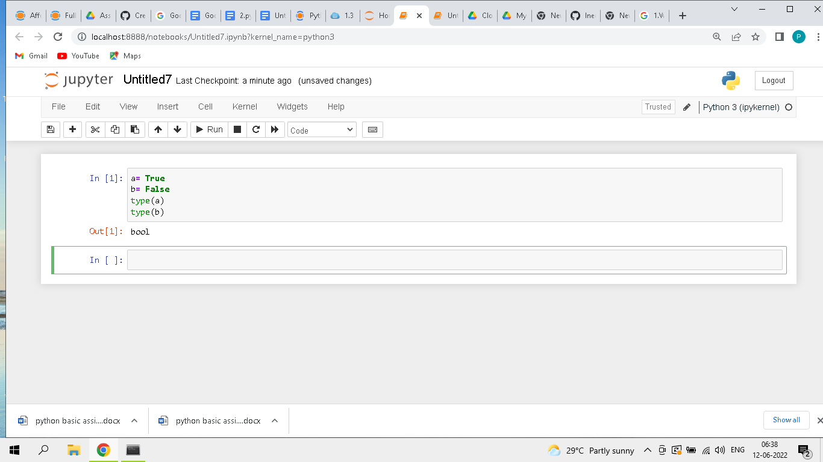

2. What are the three different types of Boolean operators?

Ans: AND , OR, NOT

3. Make a list of each Boolean operator’s truth tables (i.e. every possible combination of Boolean

values for the operator and what it evaluate ).

Ans:

False AND False is False

False AND True is False

True AND False is False

True AND True is True

False OR False is False

False OR True is True

True OR False is True

True OR True is True

NOT False is True

NOT True IS False

HERE True = 1 and False = 0

### TRUTH TABLE FOR AND

A B OUTPUT

0 0 0

0 1 0

1 0 0

1 1 1

### TRUTH TABLE FOR OR

A B OUTPUT

0 0 0

0 1 1

1 0 1

1 1 1

### TRUTH TABLE FOR NOT

A OUTPUT

1 0

0 1

4. What are the values of the following expressions?

(5 > 4) and (3 == 5)

not (5 > 4)

(5 > 4) or (3 == 5)

not ((5 > 4) or (3 == 5))

(True and True) and (True == False)

(not False) or (not True)

Ans:

False

False

True

False

False

True

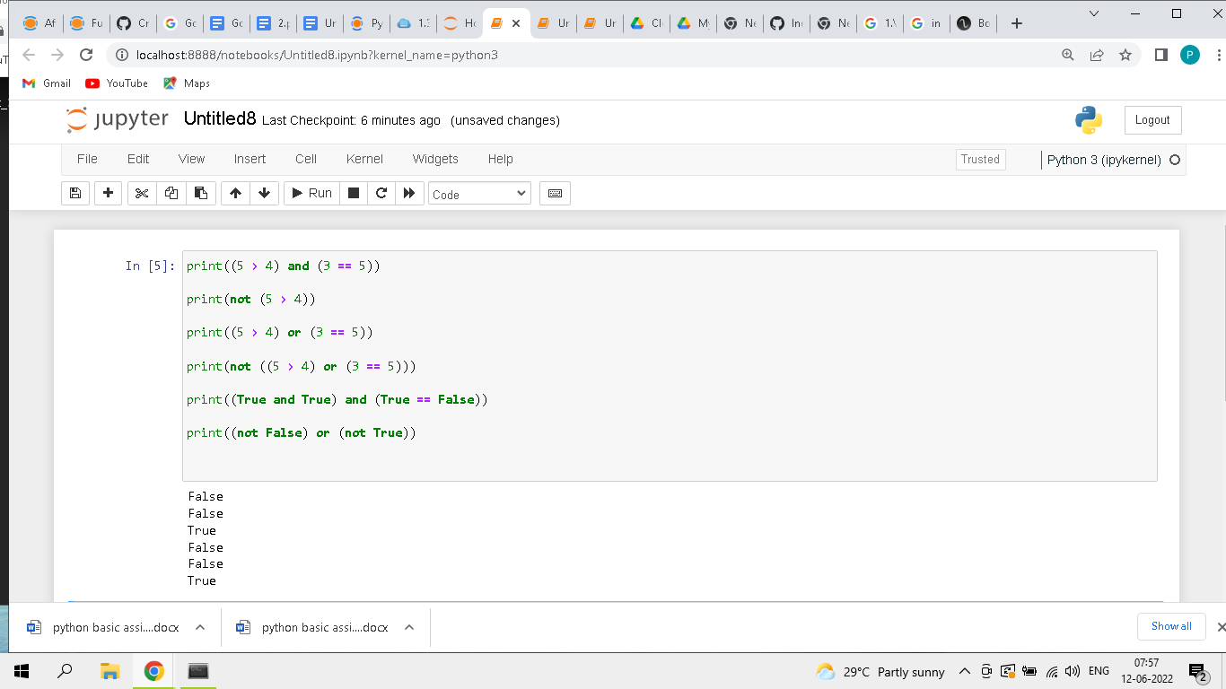

5. What are the six comparison operators?

Ans: == , < , > , != , <= , >=

6. How do you tell the difference between the equal to and assignment operators?Describe a

condition and when you would use one.

Ans: The “=” is an assignment operator that is used to assign the value on the right to the variable on the left. The '==' operator checks whether the two given operands are equal or not. If so, it returns true. Otherwise it returns false.

7. Identify the three blocks in this code:

spam = 0

if spam == 10: #1st block

print(‘eggs’)

if spam > 5: #2nd block

print(‘bacon’)

else: #3rd block

print(‘ham’)

print(‘spam’)

print(‘spam’)

8. Write code that prints Hello if 1 is stored in spam, prints Howdy if 2 is stored in spam, and prints

Greetings! if anything else is stored in spam.

Ans:

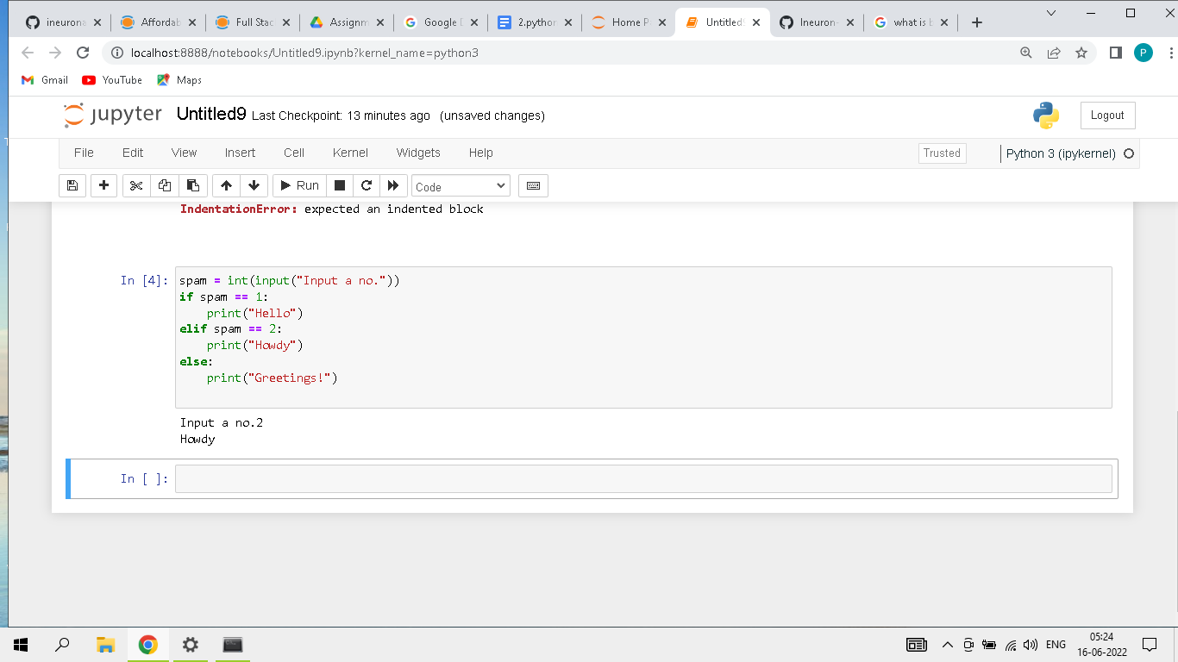

9.If your program is stuck in an endless loop, what keys you’ll press?

Ans: If the program is stuck in an endless loop I will press ctrl+c.

10. How can you tell the difference between break and continue?

Ans: The main difference between both the statements is that when break keyword comes, it terminates the execution of the current loop and passes the control over the next loop or main body, whereas when continue keyword is encountered, it skips the current iteration and executes the very next iteration in the loop.

There are 2 screenshots given below : first one foe break example and second one for continue example

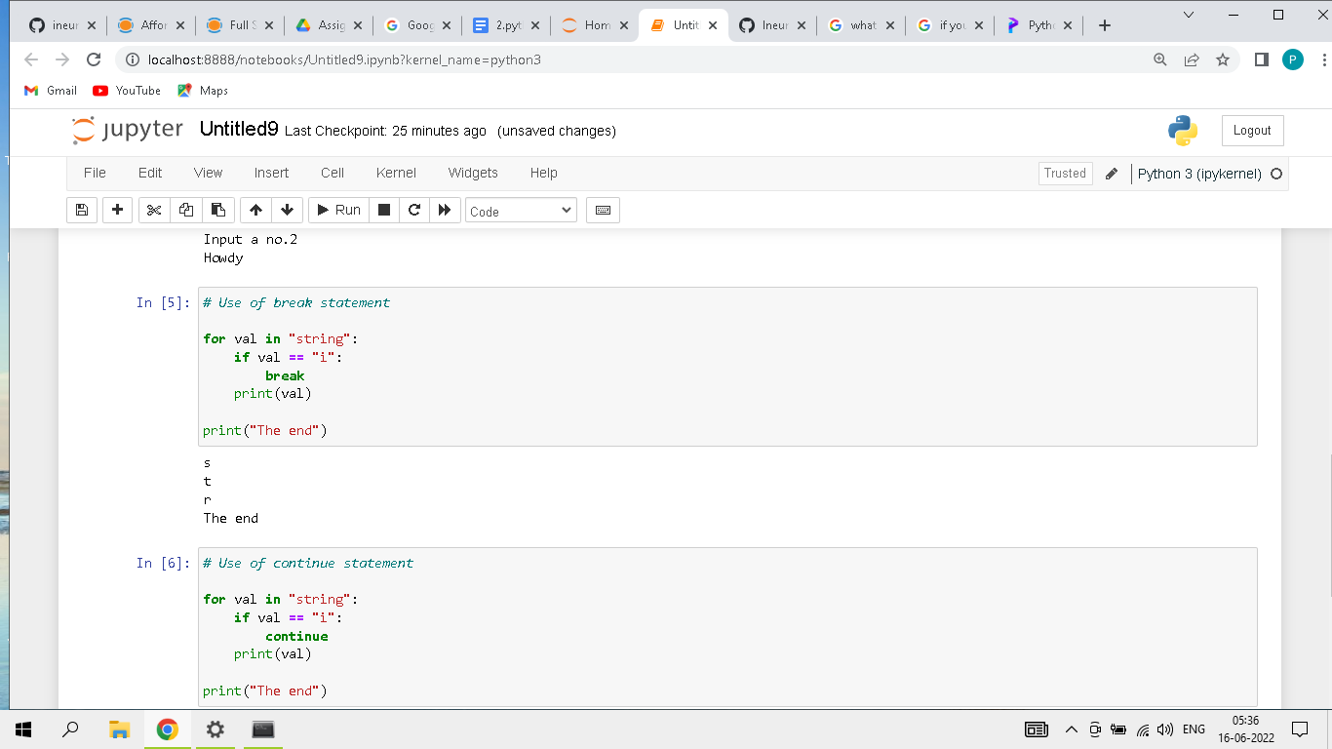

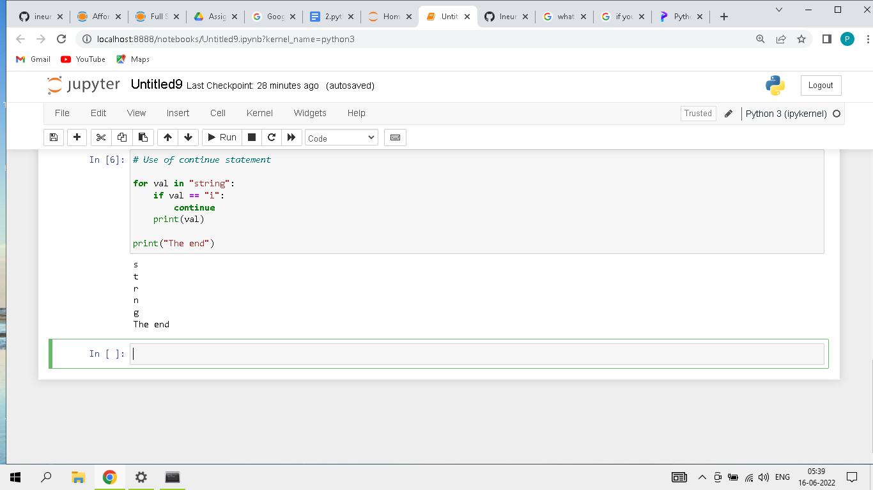

11. In a for loop, what is the difference between range(10), range(0, 10), and range(0, 10, 1)?

Ans: Firstly attached two screenshots regarding the program.

The range(10) call ranges from 0 up to (but not including) 10, range(0, 10) tells the loop to start at 0, and range(0, 10, 1) tells the loop to increase the variable by 1 on each iteration.

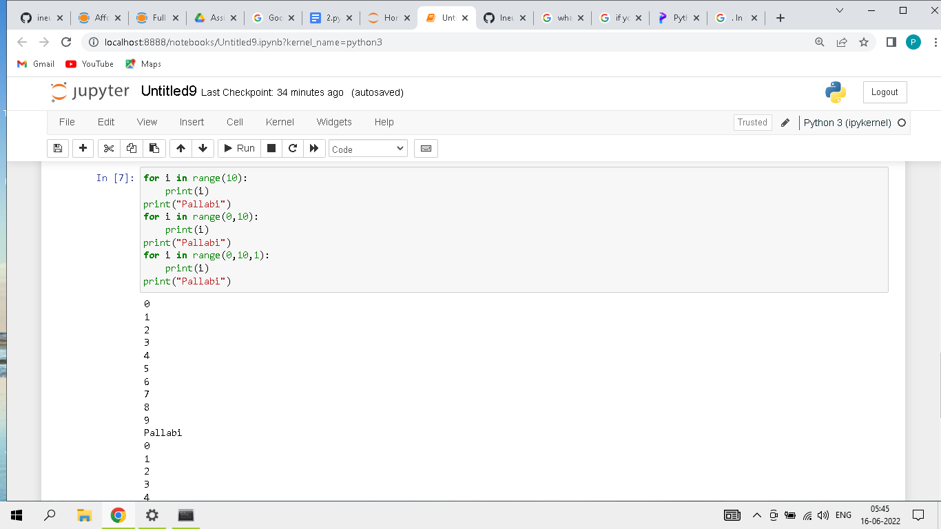

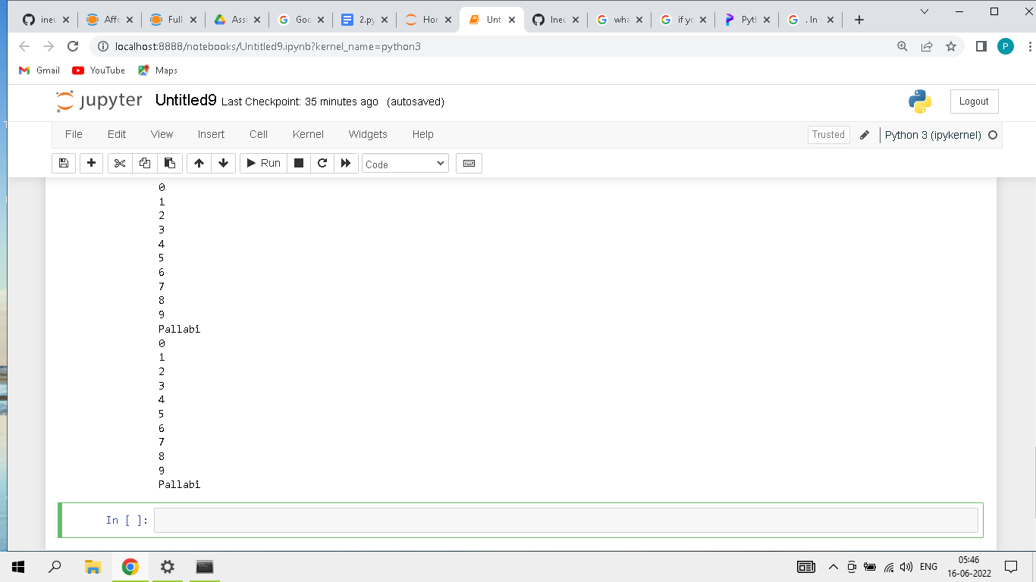

12. Write a short program that prints the numbers 1 to 10 using a for loop. Then write an equivalent

program that prints the numbers 1 to 10 using a while loop.

Ans: for loop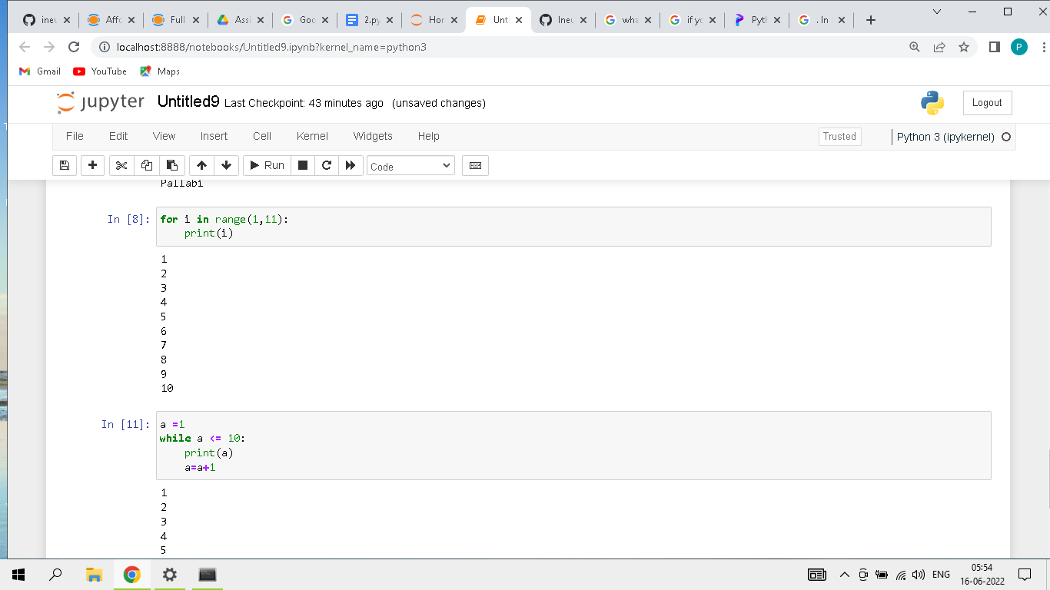

while loop

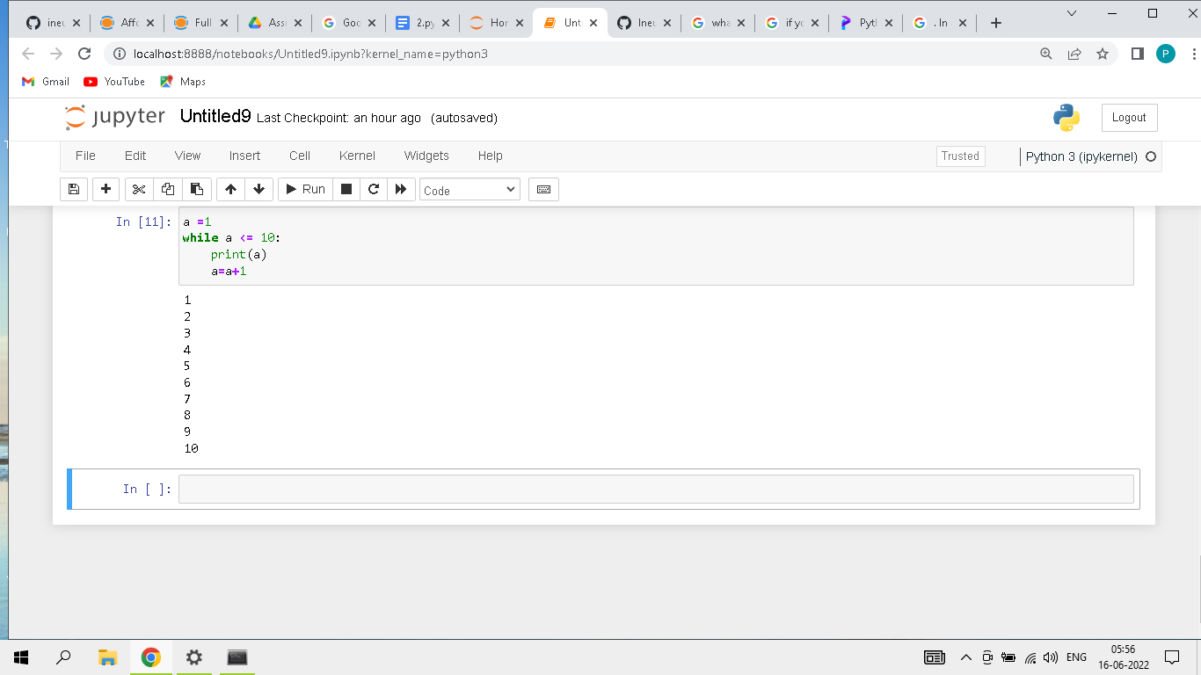

13. If you had a function named bacon() inside a module named spam, how would you call it after

importing spam?

Ans: This function can be called with spam.bacon().